Physics 20 Lesson 15

Forces & Dynamics – Problem Solving

# Forces and motion

When we solve problems related to the dynamics of a given situation, we are trying to understand how the forces acting on an object produce the current motion or a change in motion. There are usually several forces acting on an object. Some of the forces we will be dealing with are described below.

## Fg – Weight

The **weight** or **force due to gravity** on an object is due to the attraction between the mass of the object and mass of the Earth (see Lessons 21 and 22). It is the force due to gravity that pulls a ball thrown into the air back to the ground. It is also the force that pulls you down into your chair, assuming you are sitting.

## FN – Normal force

When an object is placed on a surface, like a table for example, the object is being pulled down by gravity into the table. The table surface responds to the force of gravity by pushing back up on the object. This **responding** force is called the **normal force**. (The word “normal” refers to the 90o angle between the surface of the table and the contact force. The words normal, perpendicular, and right can all refer to a 90o angle.)





For the rabbit illustrated to the right, the downward force of gravity  is balanced by the upward force  exerted by the surface on the rabbit.





(The **absolute value symbols** around a vector symbol indicate that we are talking about the **magnitude** of the vector only.)

There are three important things to note:

1. When you sit in a chair the force of gravity pulls you down into the chair. However, if you close your eyes for a moment and become aware of what you are feeling you may discover that it is not the downward force of gravity that you experience. Rather, you actually experience the seat of the chair (i.e. the normal force) pushing up on you.

2. Do not confuse **normal force** with the concept of **net force** that is described below. FN is **not** the same as FNET. They mean very different things.

3. |FN| equals |Fg| only for horizontal surfaces. When a surface is at an angle, for example an inclined plane, |FN| ≠ |Fg| (see Lesson 17).

## FA – Applied force

An applied force is a general force that indicates a push or a pull on an object. It may be applied horizontally, vertically or at any angle. When a force is applied at an angle you should immediately think in terms of its horizontal (x) and vertical (y) components.

FA

FAx

FAy

FA

FA

## Ff – Frictional force

A frictional force is any force (“stickiness” between surfaces, air resistance, etc.) that resists, retards or impedes the motion of an object. We will study frictional forces in more detail in Lesson 16, but for now we can say that **a frictional force** **acts in opposition to the motion of the object**.

# Free body diagrams and Net force

Changes in motion are rarely the result of just one force acting on an object. Consider, for example, a book being dragged across a table by a horizontal applied force. In our everyday experience we may focus on the force we are applying (FA) and may not think about the other forces acting on the book (Fg, FN, and Ff). To help us get a clear idea of all the forces acting on an object at any given time we **always** draw a **free body diagram**. A free body diagram indicates **all** of the **forces** acting on an object regardless of their cause or direction. Other quantities like velocity, displacement, acceleration, etc. are not included in a free body diagram. The free body diagram for the book is shown on the right.

•

FN

Fg

In free body diagrams the object is represented by a dot.

FA

Ff

From a properly drawn free body diagram we can write the **net force relationship** for an object. The **net force** is the **sum of all of the forces** acting on the object. For the book the net force relationship is



**Net force is not a force that you can see**. Do not think of net force as the applied force or frictional force or the force due to gravity or the normal force, rather **think of net force as the resulting effect of all these forces together**. If we were also told, that the applied force is 3.5 N and the frictional force is 3.2 N, we could then calculate the net force. As described in the previous section, |FN| = |Fg|. Therefore, the normal force acting up (+) and the weight acting down (–) add up to zero. The net force is calculated as:



Note that since **forces are vectors**, the **direction** of the forces must always be **included** in our calculation of the net force.

Consider a second example – a ball with a mass of 1.56 kg is initially at rest on a table. The free body diagram for the ball is shown on the right. From the diagram we write:

•

FN

Fg



Since  and they act in opposite directions, the net force on the ball is zero (). Since the net force is zero the ball will remain at rest.

•

FN

Fg

FA

Now we are asked to calculate the resulting velocity of the ball if we apply a horizontal force of 0.45 N for 0.25 s. We are also told that the ball is very round and that the frictional force is negligible. The free body diagram for this situation is shown on the right.



Since  and they cancel each other out, we usually do not include them in our net force equation. Instead we write



Therefore



As we saw in the previous lesson, we can calculate the acceleration of the ball using Newton’s 2nd law of motion



Using one of the kinematics equations we can calculate the final velocity of the ball



•

FN

Fg

After pushing the ball the only forces acting on the ball are the force due to gravity and the normal force of the table on the ball. The net force on the ball is zero and the ball moves at a constant velocity of +0.072 m/s.

(If you are interested, see Pearson pages 126 to 135 for a different discussion about types of forces, free body diagrams and adding forces together.)

Draw a free body diagram for a car accelerating from rest along a level street. Assuming that there is friction involved, write an expression for the net force.

•

FN

Fg

FA

Ff

Since FN and Fg are balanced forces they cancel. The net force is expressed as:



FN is the normal force, Fg is the force due to gravity, Ff is the force caused by friction, and FA is the applied force.

A car being driven on a road experiences several forces: the force of friction due to the road and the air, and the force of the engine driving the car forward. Describe what happens in the following situations:

A. The engine force is greater than the frictional force.

B. The engine force is less than the frictional force.

C. The engine force equals the frictional force.

Ff

FA

Fg

FN

•

A. 

Since FA is larger than Ff there is a positive net force. The car will have a positive (forward) acceleration.

B. 

Since Ff is larger than FA there is a negative net force. The car will have a negative (backward) acceleration.

C. 

The net force is zero. The acceleration is zero. Therefore the car will maintain a constant velocity.

For a 60 kg mass, if the frictional force is 40 N, what applied force is required to accelerate the object at 4.0 m/s2?



Draw the free body diagram

•

FN

Fg

FA = ?

Ff = 40 N



Two ice skaters, Jim (60 kg) and Bob (40 kg) are standing facing other. When Jim pushes on Bob, Bob’s acceleration is 2.0 m/s2 east. Assuming that the frictional forces are negligible, what is Jim’s acceleration?

Using Newton’s 2nd Law we calculate the net force acting on Bob.

•

FN Bob

Fg Bob

FA Bob = ?

From the free body diagram for Bob





According to Newton’s 3rd law (see Lesson 14), the action force of Jim on Bob results in a reaction force of Bob on Jim that is equal in magnitude and opposite in direction.





•

FN Jim

Fg Jim

FA Jim

From the free body diagram for Jim

Using Newton’s 2nd Law we calculate Jim’s acceleration.



A 2.0 kg object experiences a 15 N force pulling south, a 25 N force pulling west and a 20 N force pulling at 30° S of E. What is the acceleration experienced by the object?

**30°**

**•**

25 N

15 N

20 N

Recall from Lesson 10 and 11 that we add together the east-west vector components and the north-south vector components to get one resultant east-west vector and one resultant north-south vector. Therefore, we first calculate the components of all the vectors.

**30°**

Ax = 20 cos30

Ax = 17.32 N (E)

Ay = 20 sin30

Ay = 10.0 N (S)

20 N

Now we add together the components of all the vectors:

(N-S) component = 15 N (S) + 10.0 N (S) = **25.0 N (S)**

(E-W) component = 25 N (W) + 17.32 N (E) = **7.68 N (W)**

Now we add the components together tip-to-tale



❑

FNET

25.0 N

7.68 N



Using Newton’s 2nd Law we calculate the acceleration



If a 130 N east net force is applied for 2.0 seconds to a 50 kg mass at rest, what is the resulting displacement of the object?

 

A 15 kg object is pushed from rest for 5.0 s by a 60 N east force and then it is allowed to continue moving. The object eventually comes to rest. If the frictional force is 20 N, how far from its starting point does the object come to rest?

First, calculate the distance for when the 60 N force was applied.



•

FN

Fg

FA = 60 N

Ff = 20 N



Second, calculate the distance for when the object is sliding to a stop.

•

FN

Fg

Ff = 20 N



The total distance is



A force of 90 N is applied to a sled (mass 40 kg) at an angle of 30° to the horizontal. If the frictional force is 27.94 N, what is the resulting acceleration of the sled?

Unless the applied force is large enough to pull the sled off the ground, only the horizontal component of the force (Fx) will cause the wagon to accelerate horizontally.



Fx

30**°**

•

FN

Fg

FA = 90 N

Ff = 27.94 N



# Practice problems

1. A 6.0 kg cart is being pulled with a horizontal force of 25 N. If the frictional force is 15 N, what is the acceleration of the cart? (1.7 m/s2)

2. A 1200 kg car comes to a stop from a speed of 25 m/s in 6.5 s. What braking force was required? (4.6 x 103 N)

3. A 5.0 kg object experiences a 15 N force pulling north, a 25 N force pulling east and a 20 N force pulling at 30o E of S. What is the acceleration experienced by the object? (7.02 m/s2 @ 3.8o S of E)

4. A 130 N eastward force is applied for 2.0 s to a 50 kg object starting from rest on a level surface. If there is a frictional force of 50 N, what is the resulting displacement of the object? (3.2 m)

# Hand-in Assignment

1. In each case, a rock is acted on by one or more forces. All drawings are in a vertical plane, and friction is negligible (i.e. zero) except where noted. **Draw accurate free-body diagrams showing all forces acting on the rock**. Please use a ruler, and do it in pencil so you can correct mistakes. The one to the right is done as an example.

A. Suspended static rock

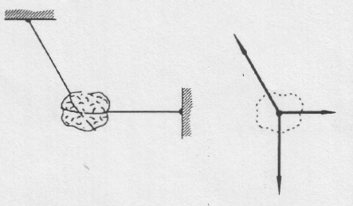







B. Rock on ground

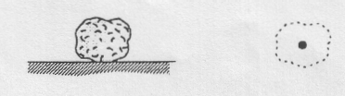

D. Suspended static rock

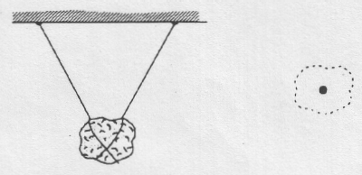

C. Suspended static rock

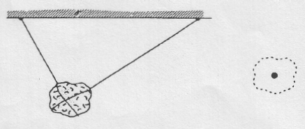

F. Rock is falling. Air friction is involved.

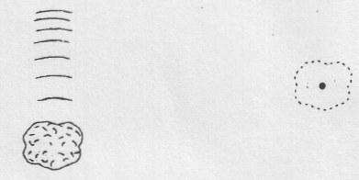

E. Rock is falling. No air friction.



G. Falling at constant (terminal) velocity.

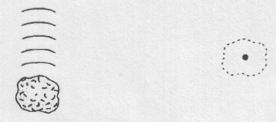

I. At the top of a parabolic trajectory.

No air resistance.

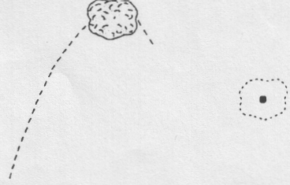

H. Rising in a parabolic trajectory.

No air resistance.

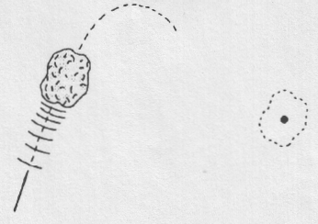

2. A 300 kg object is accelerated at 0.25 m/s2 by what unknown force? (75 N)

3. A 400 g mass at rest is acted on by a 200 N net force for 12.0 s. What is its final velocity? (6.00 x 103 m/s)

4. What is the mass of an object that is acted on by a 500 N horizontal force and a 150 N frictional force if it changes velocity from 20 m/s to 40 m/s in 2.5 s? (44 kg)

5. What is the initial velocity of a 2.2 kg object that experiences a net force of 2.50 N for 8.0 s giving it a final velocity of 70 m/s? (+61 m/s)

6. A 4000 kg vehicle travelling at 26 m/s west is slowed to 2.0 m/s west in 20 s by what braking force? (4800 N east)

7. A car of mass 1.5 x 103 kg is being driven at 20 m/s. The driver sees a massive hole 100 m ahead. What is the minimum frictional force required to stop the car in time? (3000 N)

8. A bullet of mass 20 g strikes a fixed block of wood at a speed of 320 m/s. The bullet embeds itself in the block of wood, penetrating to a depth of 6.0 cm. Calculate the average force acting on the bullet to bring it to rest? (1.7 x 104 N)

9. A 40 N push north combines with a 30 N pull east. What is the net force? (50 N @36.9o E of N)

10. Three strings are attached to an object. If one of the strings is pulled north with a force of 10 N and one of the other strings is pulled west with 15 N, what force must be applied to the third string so that the object does not move? (18.0 N @33.7o S of E)

11. A 20 kg mass, initially at rest, is subjected to the following forces: 30 N at 30o north of east, 40 N south, and 50 N at 45o south of west. What is the acceleration of the mass? (3.05 m/s2 @ 8.8o W of S)

12. An 8.0 g bullet travelling at 400 m/s passes through a heavy block of wood in 4.0 x 10-4 s and emerges with a speed of 100 m/s. (a) With what average force did the wood oppose the motion of the bullet? (b) How thick is the block of wood? (–6.0 x 103 N, 1.0 x 10-1 m)

13. A 1600 kg car is at a stop light on a level, horizontal road. There is an average frictional force of 680 N acting on the car.

a) When the light turns green the driver accelerates the car to a speed of 72 km/h in 25 s. What was the applied force on the car during this time? (+1960 N)

b) The driver then maintains a constant speed of 72 km/h for 6.5 km. What was the applied force on the car during this time? (+680 N)

c) When the driver sees a red light ahead he slows to a stop over 32 s. What was the applied braking force on the car during this time? (–320 N)

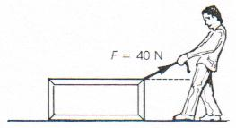

14. A man drags a package across the floor with a force of a 40 N, as shown. The mass of the package is 10 kg. If the acceleration of the package is 3.5 m/s2 and friction can be neglected, at what angle to the horizontal does the man pull? (29o)

15. A spring is compressed between two marbles.

A

B

When the spring is released,

A

B

marble A (mass = 20.0 g) is projected from rest to –15.0 m/s in 0.0350 s. What is the mass of marble B if it experiences a velocity change from rest to +22.0 m/s in 0.0350 s? (13.6 g)